1. COMP1002 and COMP1409

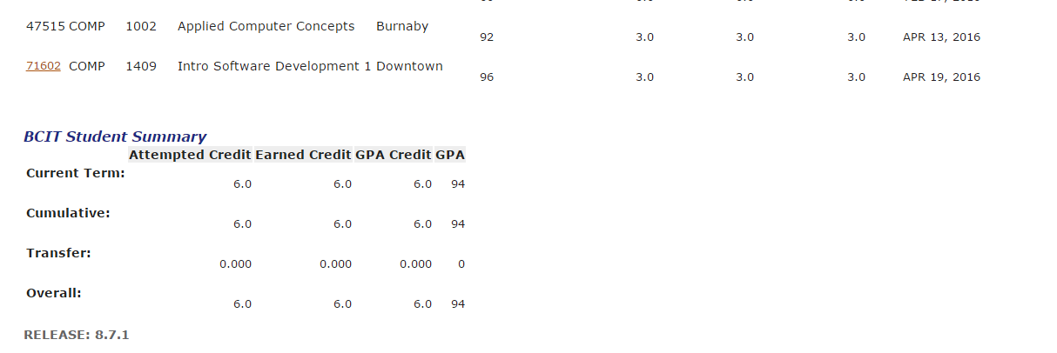

1. Java from Paul

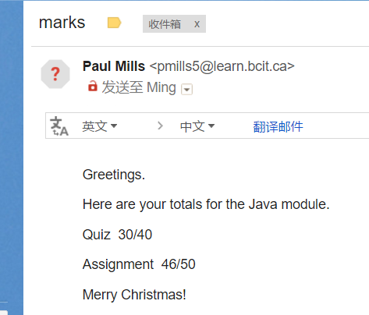

1. CSS and HTML 5 part assignments





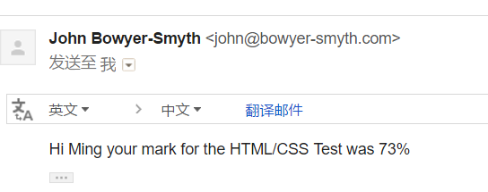

I had sent email to John asking the final scores, and have not gotten it.

1. JavaScript from Jason : Scores : ***89.5 (I calculated)***

|  |  |
| --- | --- |
| ***89.51485*** | |
| ***Course Attributes*** | |
| **CRN:** | 33450 |
| **Subject:** | SSDP |
| **Course:** | 2501 |
| **Section:** | 0 |
| **Title:** | Systems Foundations 2 |
| **Credits:** | 12.000 |
| **Final Grade:** |  |
|  |  |

|  |  |  |  |  |  |  |
| --- | --- | --- | --- | --- | --- | --- |
| ***Components*** | | | | | | |
| **Title** | **Score/Out Of** | **Percentage** | **Letter Grade** | **Must Pass** | **Weight** | **Subcomponents** |
| LAB01 - Lab 01 Note | 10/10 | 100 | 100 | N | 2 | None |  |
| LAB02 - Lab 02 | 10/10 | 100 | 100 | N | 4 | None |  |
| LAB03 - Lab 03 [Note](javascript:FloatingWindow('Lab%2003','find%20a%20combination%20of%20digitsin%20which%20every%20digit%200-9%20is%20there%20exactly%20onceand%20in%20which%20the%20number%20made%20by%20the%20first%20n%20digitsis%20divisible%20by%20n')) | 10/10 | 100 | 100 | N | 4 | None |  |
| LAB04 - Lab 04 Note | 10/10 | 100 | 100 | N | 3 | None |  |
| LAB05 - Lab 05 [Note](javascript:FloatingWindow('Lab%2005','get%20the%20jQuery%20validation%20plugin%20working%20as%20in%20the%20demoAND%20ALSOmake%20it%20so%20that%20shoe%20size%20must%20be%201-15%20inclusiveand%20birth%20year%20must%20be%201900-2016%20inclusiveand%20when%20you%20double%20click%20the%20URL%20text%20box,%20open%20the%20link%20UNLESS%20it's%20tourdefrance.com')) | 10/10 | 100 | 100 | N | 3 | None |  |
| LAB06 - jquery plugins Note | 6/6 | 100 | 100 | N | 8 | None |  |
| LAB07 - animations Note | 10/10 | 100 | 100 | N | 4 | None |  |
| assign1 - assignment 1 Note | 72/72 | 100 | 100 | N | 8 | None |  |
| LAB 8 - AJAX lab | 10/10 | 100 | 100 | N | 4 | None |  |
| QUIZ01 - Quiz 1 | 7.5/12 | 62.5 | 63 | N | 5 | None |  |
| QUIZ02 - Quiz 2 | 23.5/27 | 87.03 | 87 | N | 5 | None |  |
| QUIZ03 - Quiz 3 | 10/12 | 83.33 | 83 | N | 4.5 | None |  |
| QUIZ04 - quiz 4 | 7/9 | 77.77 | 78 | N | 5 | None |  |
| QUIZ05 - create a quiz | 10/10 | 100 | 100 | N | 3 | None |  |
| QUIZ06 - DOM scripting Note | 10/10 | 100 | 100 | N | 4 | None |  |
| BONUS - firebase db | 0/1 | 0 | 0F | N | 0 | None |  |
| QUIZ07 - AJAX quiz | 9/10 | 90 | 90 | N | 3.5 | None |  |
| project - Letter Game [Note](javascript:FloatingWindow('Letter%20Game','work%20with%20the%20november%2023%20code%20on%20Share%20Outnow%20create%20a%20game%20using%20that%20skeleton%20of%20codedue%20Dec%207%202016%20in%20classprepare%20a%20demonstration%20for%20that%20date%20too')) | 8.75/10 | 87.5 | 88 | N | 30 | None | jingwest2637.netne.net/javascript/39.html |

1. PHP

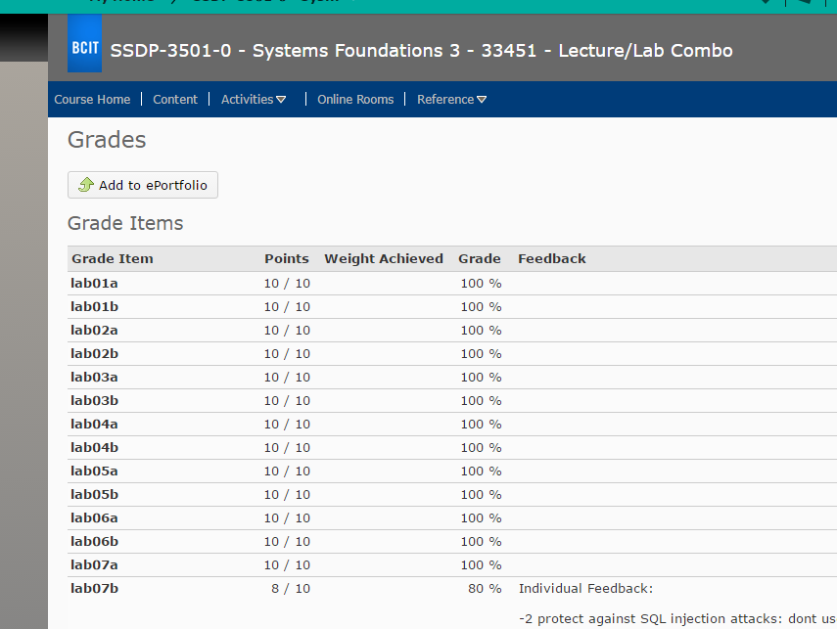

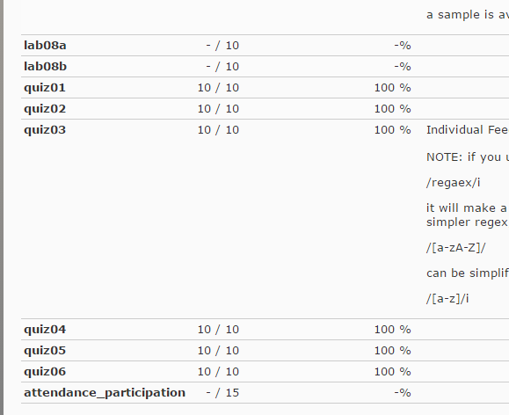

I do not have Jeff’s email, and only get these online.